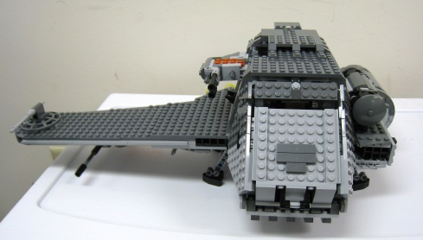**Name: The Twilight**

**Originates in: Denmark**

**Invented by: The Lego Group**

**Year: 1949**

**Category: Construction**

**Popular construction toy which can be interlocked to create different objects. The Twilight was released on July 26, 2008 as part of the LEGO Star Wars.**